1. nodeJSMachine - machine where NodeJs has been hosted)
2. blockchainMachine – machine where block chain has been hosted
3. Scenario 1- Enabling only TCP Ports and Disabling UDP Ports on both nodeJSMachine and blockchainMachine.
4. Scenario 2- Disabling TCP Ports on nodeJSMachine and enabling all TCP Ports on blockchainMachine
5. Scenario 3- Enabling all TCP Ports on nodeJSMachine and disabling all TCP Ports on blockchainMachine.
6. Scenario 4- Only 8081 enabled on nodeJSMachine for web entry and enabling all TCP ports on blockchainMachine
7. Scenario 5- Port 80 enabled on nodeJSMachine.
8. Scenario 6- Port 80 enabled for inbound and All TCP ports outbound enabled for nodeJS machine and all TCP Ports enabled for blockchainMachine
9. Scenario 7- Enabled port 7050(Orderer) on blockchainMachine.
10. Scenario 8- Enabled 7050,7051,7053,7054,8051,8053,8054,9051,9053,9054,10053,10054

On blockchainMachine.

1. Scenario 9- Enabled Scenario 8 ports plus port 80 on blockchainMachine. No changes on nodeJSMachine
2. Scenario 10- Removing 10053,10054 from blockchainMachine.
3. Scenario 11: - Scenario 10 for both nodeJSMachine and blockchainMachine.

|  |  |  |  |  |  |
| --- | --- | --- | --- | --- | --- |
| Scenario | Machine 1(TCP Ports) | Machine 1(UDP Ports) | Machine 2(TCP Ports) | Machine 2 (UDP Ports) | Status |
| 1 | All TCP Enabled | None Enabled | All TCP Enabled | None Enabled | Worked |
| 2 | All TCP Disabled | None Enabled | All TCP Enabled | None Enabled | Web was not able to connect with nodejs. |
| 3 | All TCP Enabled | None Enabled | All TCP Disabled | None Enabled | Not able to fetch data from block chain |
| 4 | 8081 Enabled | None Enabled | All TCP Enabled | None Enabled | Web not able to connect with nodejs |
| 5 | 80 Enabled | None Enabled | All TCP Enabled | None Enabled | Able to login in (i.e web connected with nodejs) but not able to connect with block chain as only port 80 was enabled for outbound |
| 6 | 80 enabled for inbound and all TCP ports enable for outbound | None Enabled | All TCP enabled | None Enabled | Working  g |
| 7 | 80 enabled for inbound and all TCP ports enable for outbound | None Enabled | Port 7050 enabled | None Enabled | Not able to connect to block chain. |
| 8 | 80 enabled for inbound and all TCP ports enable for outbound | None enabled | 7050,7051,7053,7054,8051  8053,8054,9051,9053,9054  10053,10054 | None Enabled | Not Working |
| 9 | 80 enabled for inbound and all TCP ports enable for outbound | None enabled | 7050,7051,7053,7054,8051  8053,8054,9051,9053,9054  10053,10054,80 | None Enabled | Not Working |
| 10 | 80 enabled for inbound and all TCP ports enable for outbound | None enabled | 7051,7053,7054,8051  8053,8054,9051,9053,9054  ,80 | None Enabled | Not Working |
| 11 | 7050,7051,7053,7054,8051  8053,8054,9051,9053,9054  10053,10054,80 | None enabled | 7050,7051,7053,7054,8051  8053,8054,9051,9053,9054  10053,10054,80 | None enabled | Not Working |

SCENARIO 1: -

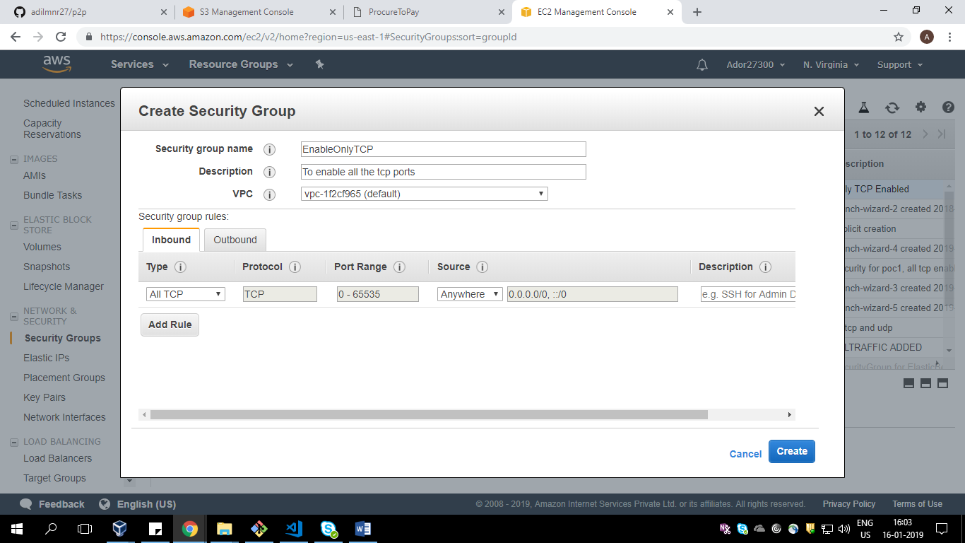

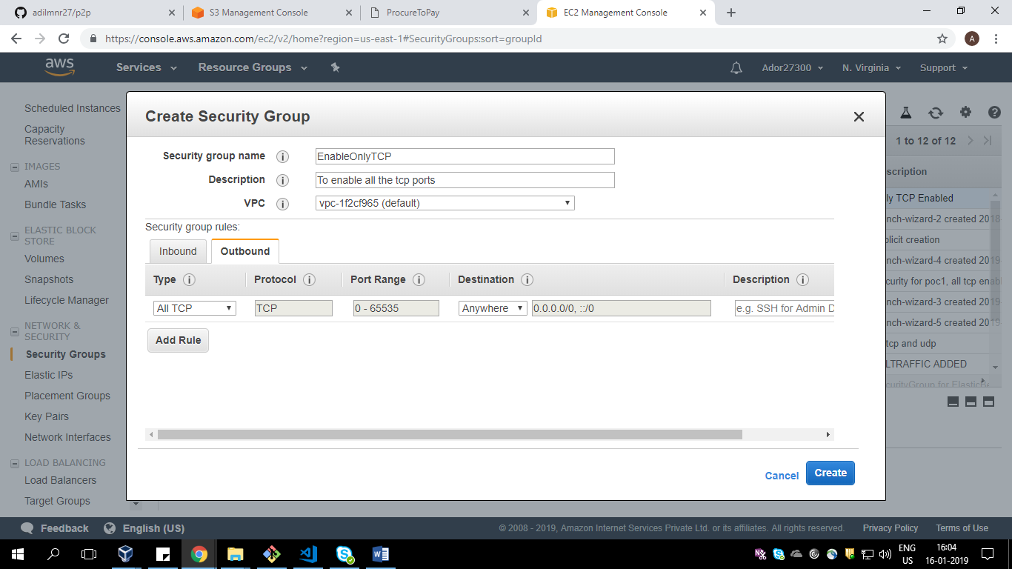

Scenario 2) :-

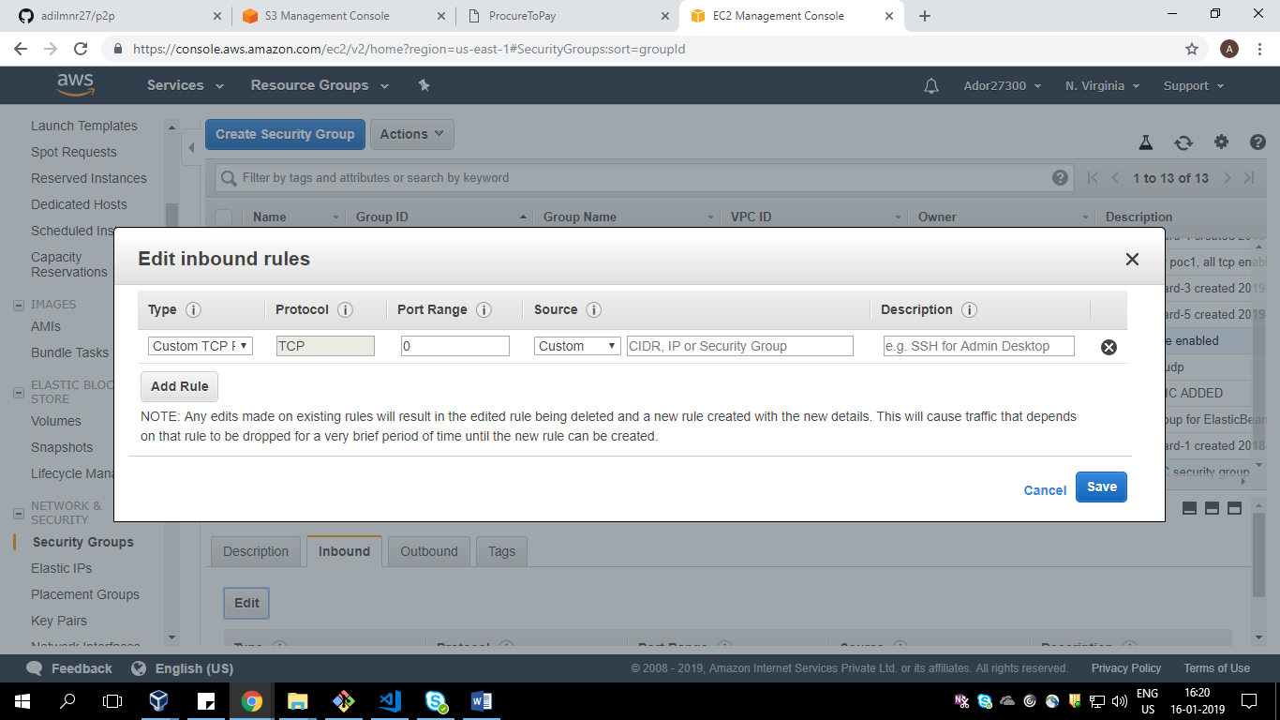

Scenario 3)

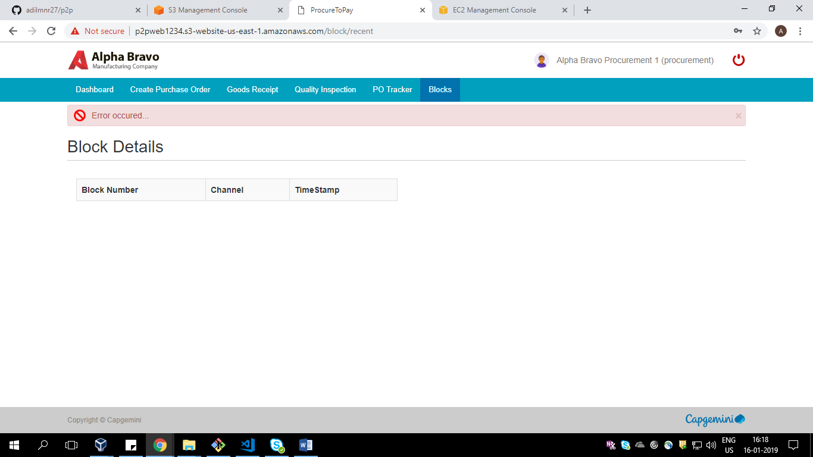



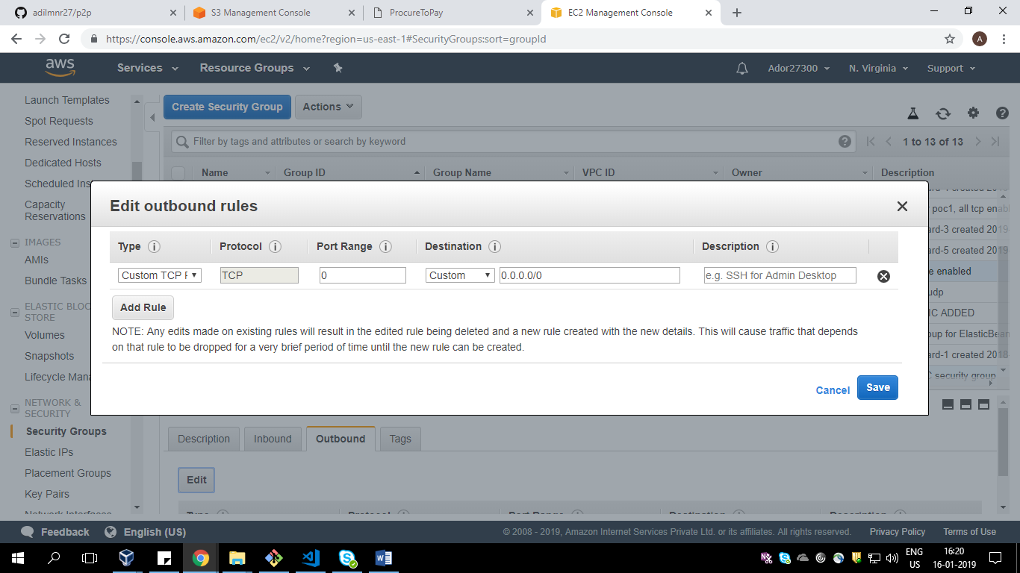

Scenario 4 )

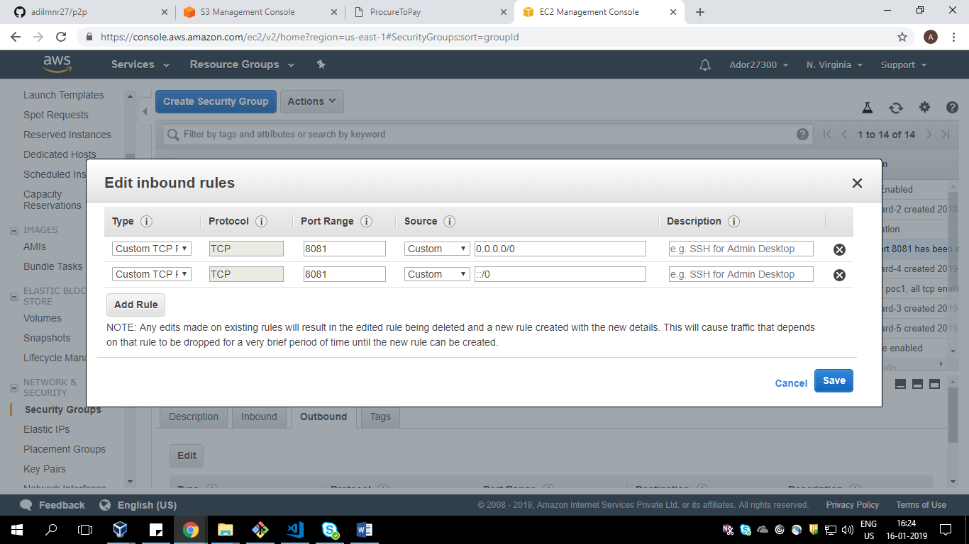

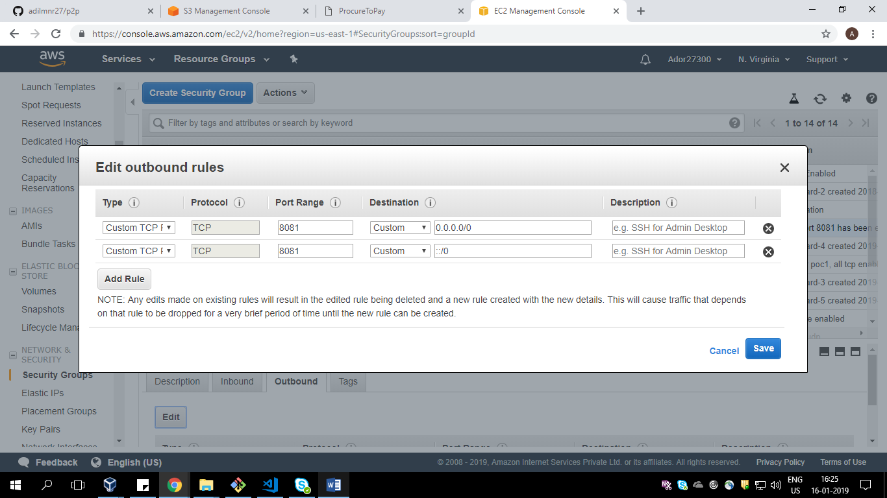

Scenario 5)

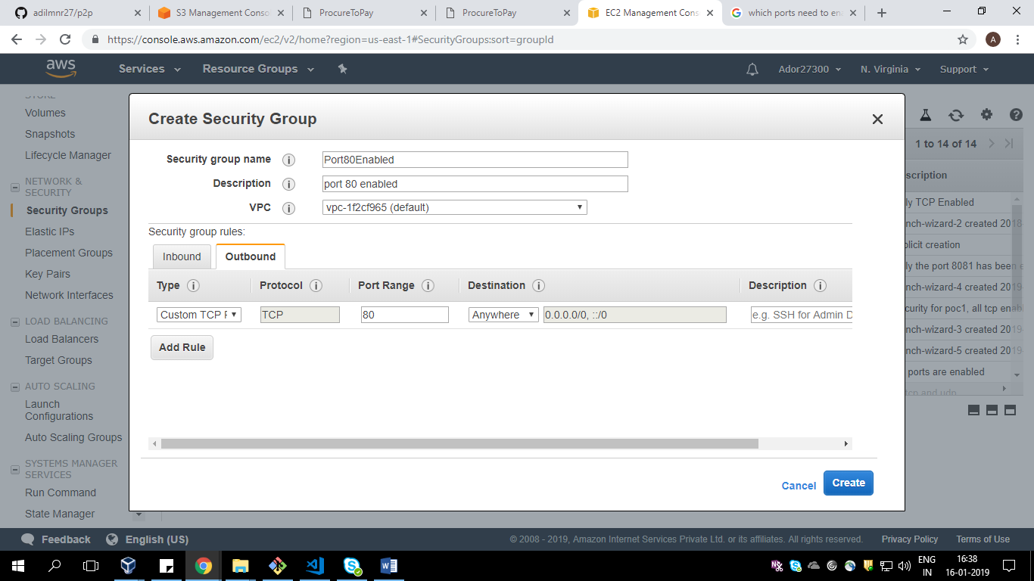

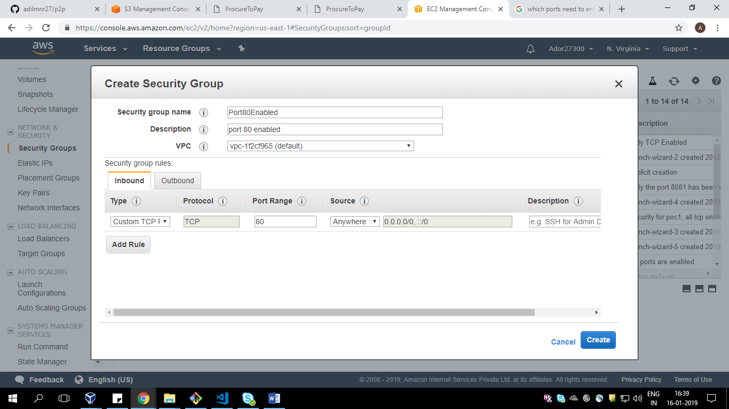

Scenario 6)

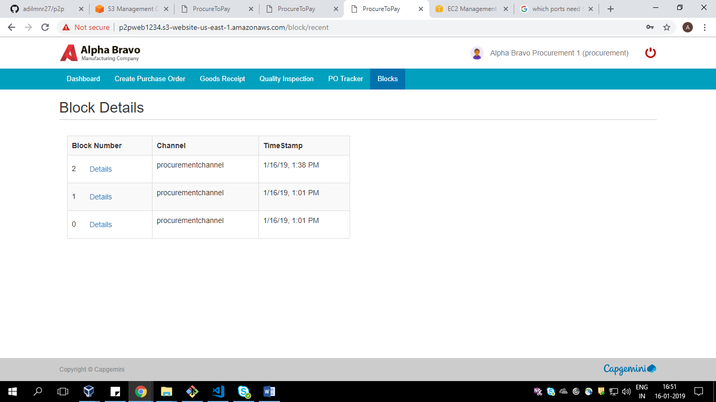

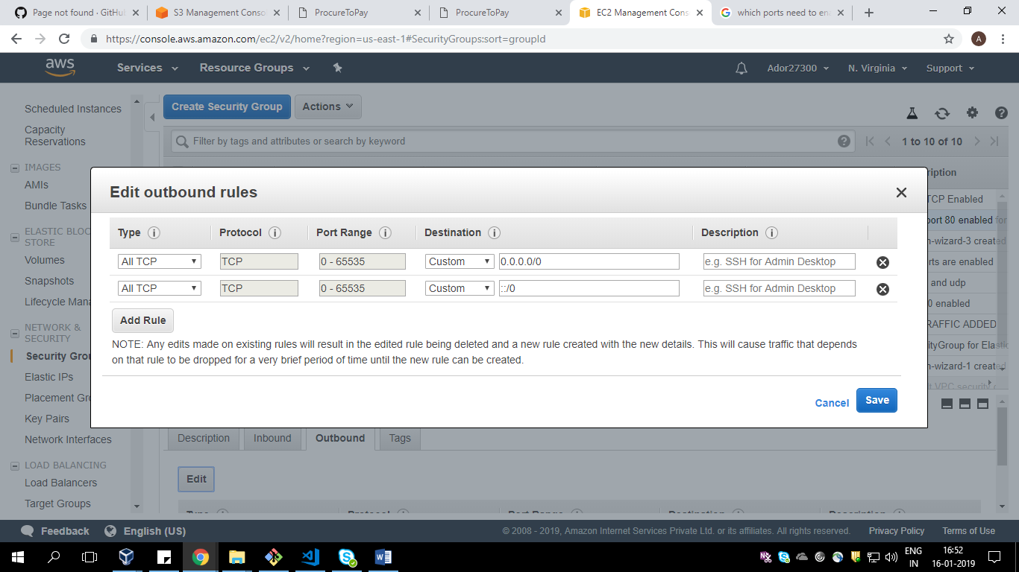

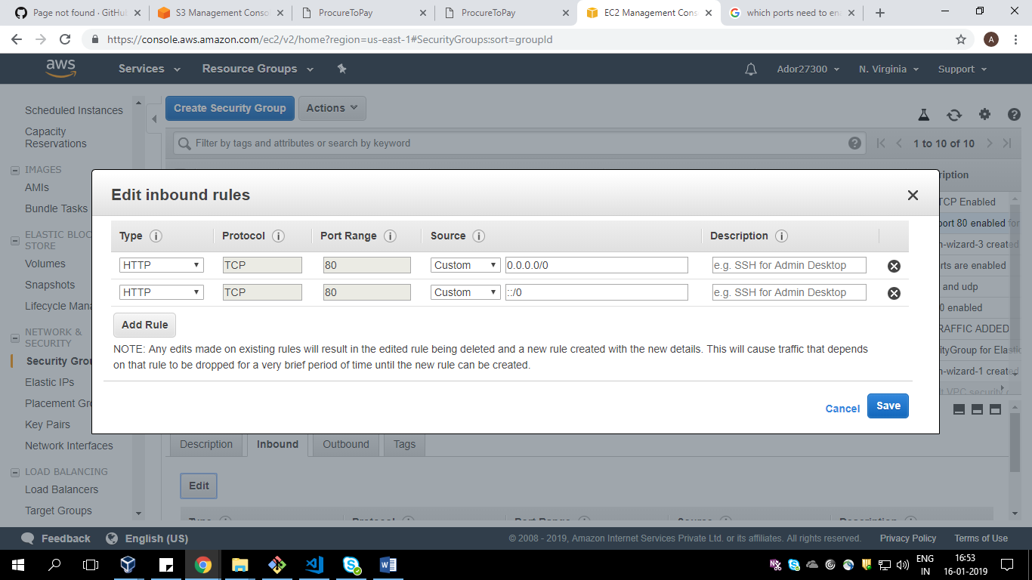

Scenario 7)

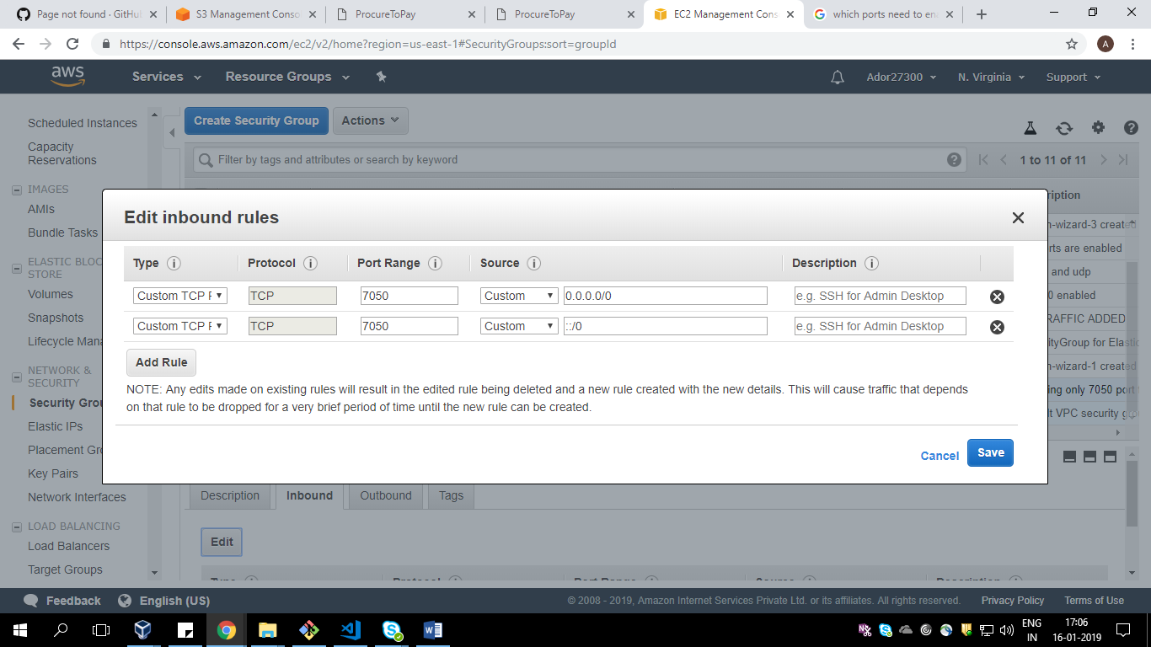

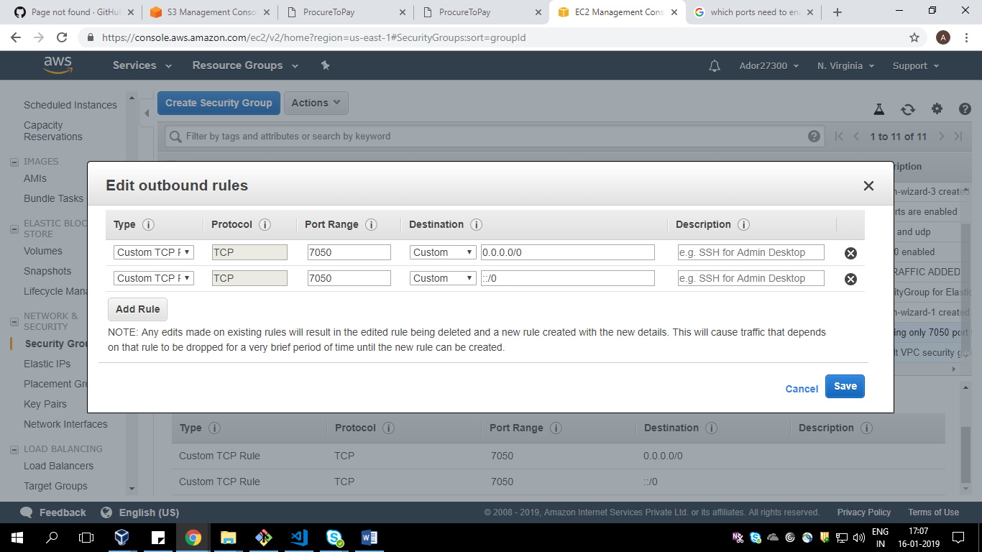

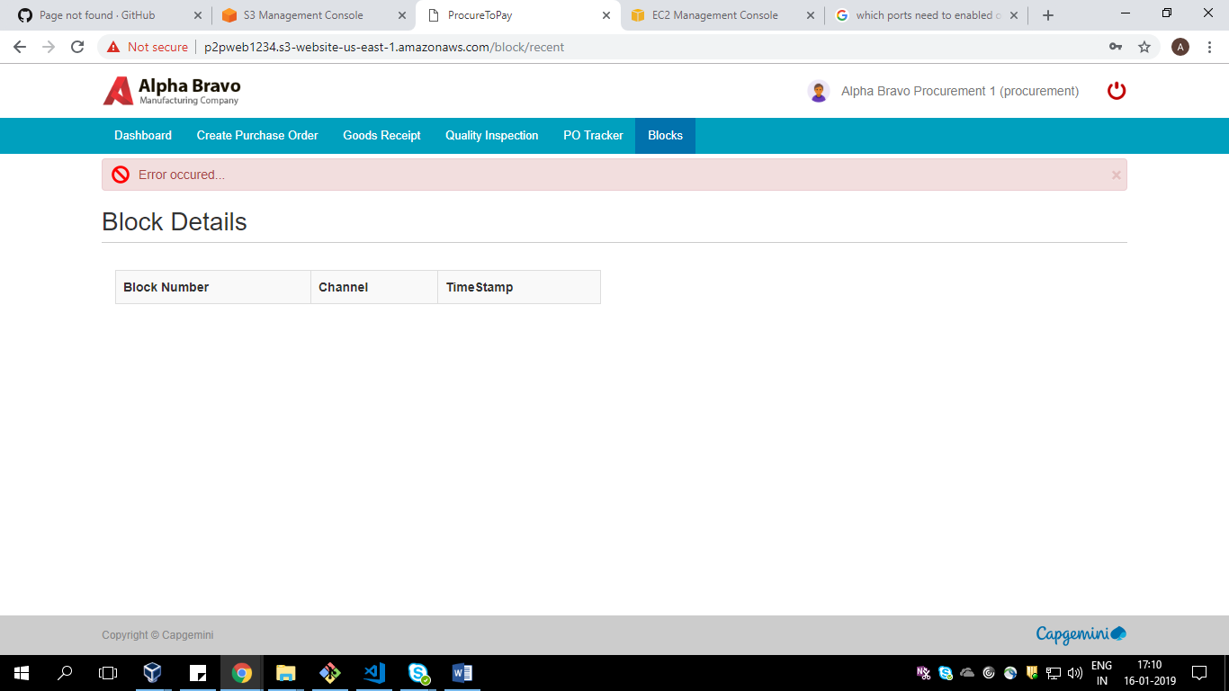

8)

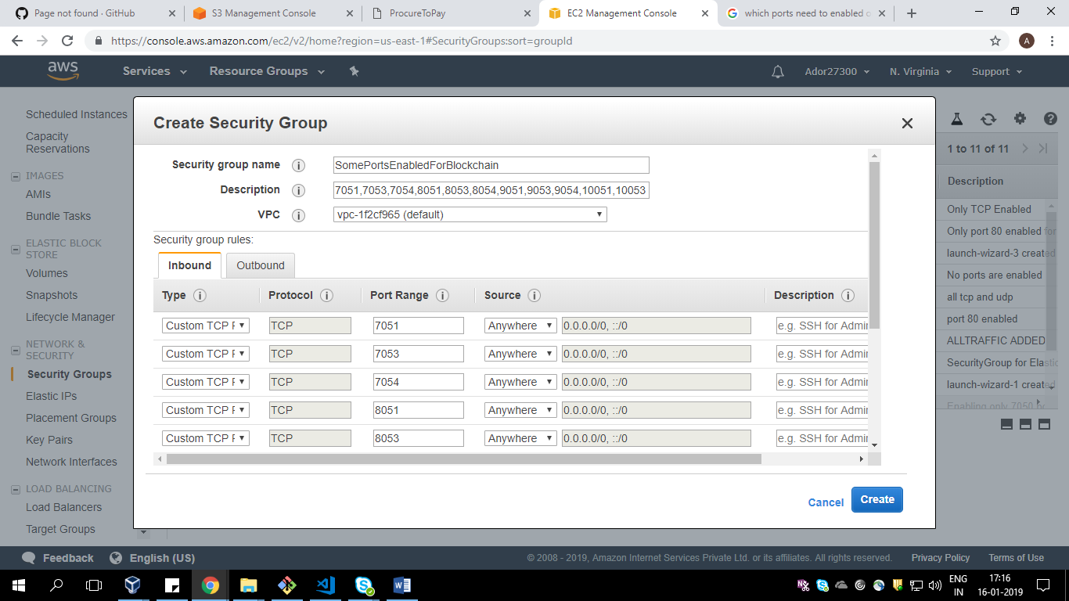

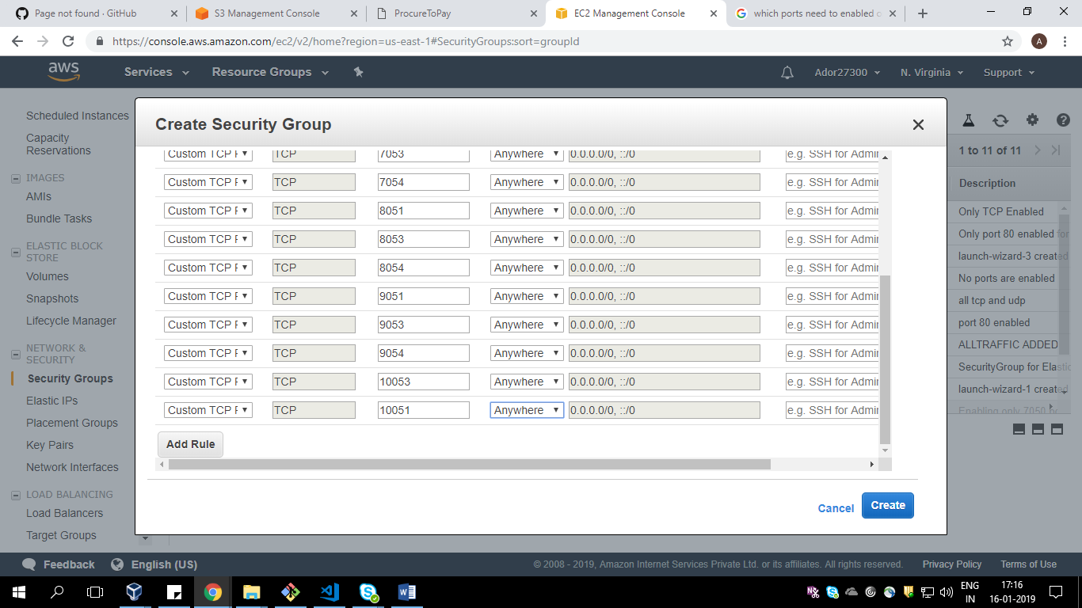

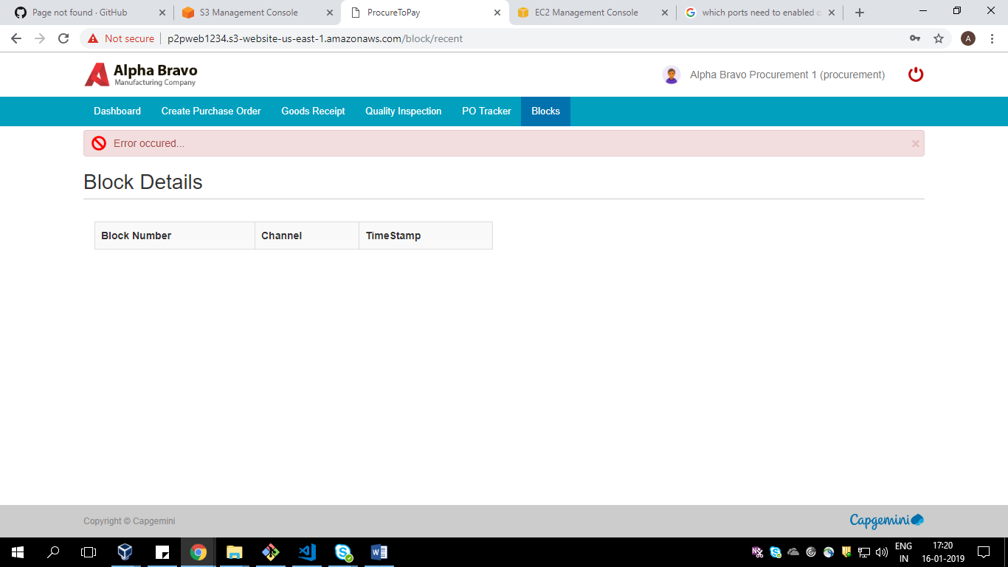

Scenario 10)

